**PROJECT FLOW DOCUMENT FOR REWARD POINTS CALCULATION PORTAL**

**DETAILS:**

|  |  |
| --- | --- |
| NAME | HARI VIKASSHINI V C |
| ROLL NO | 7376221CS162 |
| PROJECT ID | 9 |
| PROBLEM STATEMENT | REWARD POINTS CALCULATION PORTAL FOR TAC PROJECTS |
| SEAT NUMBER | 49 |

**PROBLEM STATEMENT:**

Calculating the sum of reward points for the TAC review, initial and final reports, worklog and plagiarism percentage is a tedious task if it is done manually. To address this, if all these marks are calculated and brought to a common portal, it would be easier to calculate the total reward points.

**FEATURES OF THE PROJECT:**

**ADMIN FEATURES:**

**Allocation of Marks:**

The admin login allows administrators to allocate marks for both the initial submission report and the final submission report of TAC projects. This feature enables fair assessment of the project's progression and quality.

**Aggregate Mark Calculation:**

The admin dashboard will aggregate marks allocated by the admin, reviewer, and data fetched from the database for work log and plagiarism. These aggregated marks will constitute the total reward points earned by the students, providing a comprehensive overview of their performance.

**Visibility:**

Admins will have privileged access to view the total reward points of all the projects using the project ID. facilitating informed decision-making regarding rewards and recognition.

**REVIEWER FEATURES:**

**Mark Allocation for TAC Review:**

Reviewers, assigned to evaluate student projects, can allocate marks based on the quality of the projects for each rubric and innovative contributions.

**Assessment of Team Communication:**

Reviewers will also assess the effectiveness of team communication throughout the project duration, ensuring that students actively collaborate and communicate.

**Contribution Tracking:**

Reviewers' inputs will be seamlessly integrated into the total reward points calculation, providing a comprehensive assessment of student performance.

**STACK:**

|  |  |
| --- | --- |
| FRONT END | REACT JS |
| BACK END | SPRING BOOT |
| DATABASE | MYSQL |
| API | REST FUL API |

**ADDITIONAL FUNCTIONALITIES:**

1)Database Integration:

The reward points calculation portal will integrate with a database system to retrieve and store relevant data, including work log marks and plagiarism assessment marks, ensuring accuracy and reliability in reward point calculation.

2)User Authentication:

Robust user authentication mechanisms will be implemented to ensure data security and prevent unauthorized access.

3)Scalability:

The portal will be designed to accommodate multiple projects and users simultaneously, ensuring scalability.

**ADMIN INTERFACE:**

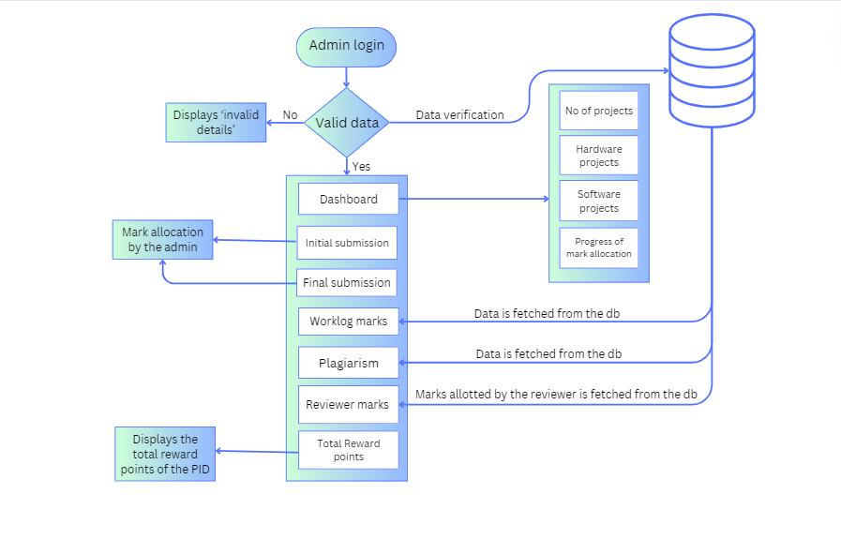

**REVIEWER INTERFACE:**

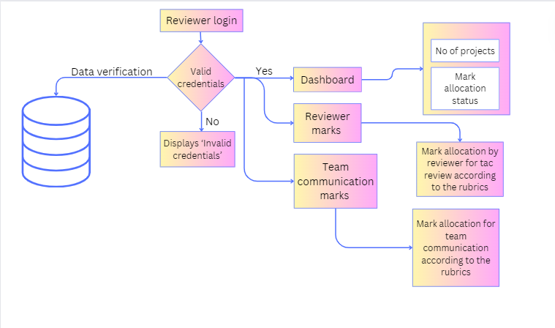

**BACKEND:**

**ER-DIAGRAM:**

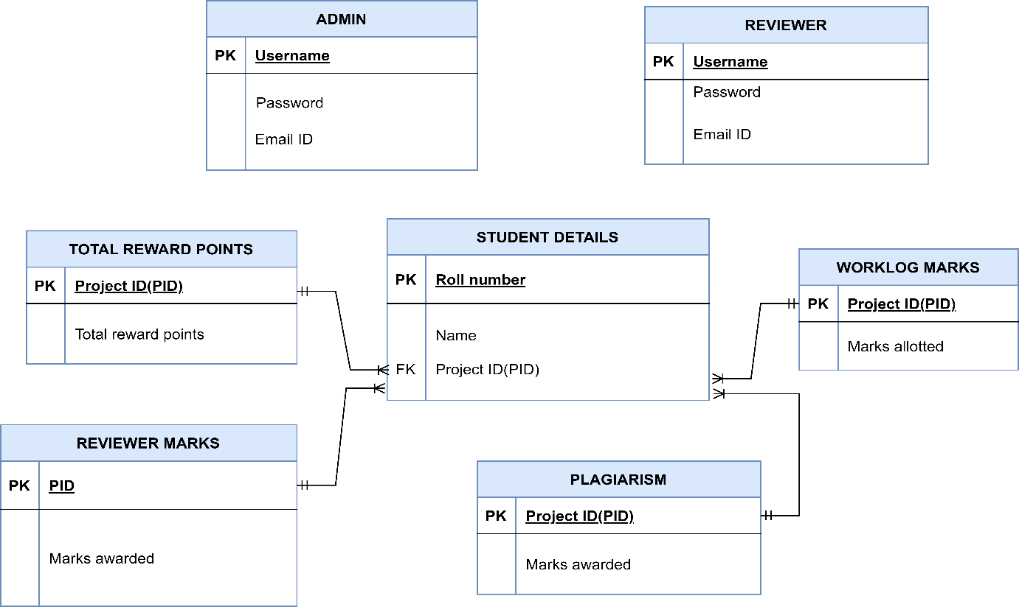

**SCOPE OF THE PROJECT:**

* The project will focus on developing user-friendly interfaces for both the admin and reviewer logins, facilitating efficient allocation and assessment of marks for student projects. Functionalities such as mark allocation, aggregation and visibility of total reward points will be implemented within the portal, ensuring seamless management of student project evaluations.
* Integration with a robust database system will be a key aspect of the project, enabling the retrieval and storage of essential data such as work log marks and plagiarism assessments. Emphasis will be placed on implementing stringent security measures to safeguard sensitive information and prevent unauthorized access to the portal, ensuring data integrity and user confidentiality.